Social Media Posts for Real Wealth® Weekly
Tax strategies for Roth conversions
with Jim Silbernagel
For the week starting on 09.12.2022

Sample BD disclosure:
(All Broker Dealer Sponsors have agreed-upon language.)
This content has been approved with the understanding that you may only share this approved social media content if you have an approved social media account.

FACEBOOK POSTS
Post 1:
This quote is especially true when it comes to your financial planning…Have a great week! https://realwealthmedia.com

Post 2:
With over three decades in the insurance and financial industry, Jim Silbernagel brings his expertise on to this week’s program to discuss Roth conversions. Is a Roth right for you? Listen to the show and let’s chat! https://realwealthmedia.com
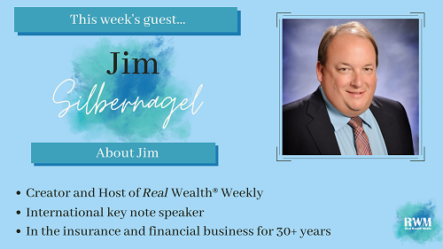

Post 3:
With the pending changes of tax brackets and tax laws, it’s important to know how these changes could impact your financial future. This week’s show fills the gaps on your tax strategies and helps set the stage for appropriate planning! https://realwealthmedia.com

Post 4:
Looking to convert? Here’s what you should know…https://realwealthmedia.com
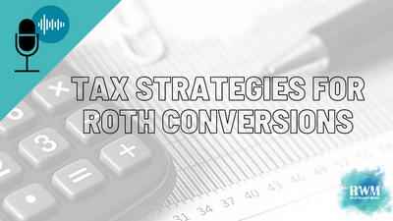

Post 5:
Looks like this guy has been waiting for a little too long…Don’t wait! Get a plan in place! https://realwealthmedia.com

TWITTER/LINKEDIN POSTS

Tweet 1:
When it comes to planning your #finances starting the planning process is the most important step! https://realwealthmedia.com

Tweet 2:
This week, Veteran Financial Professional Jim Silbernagel discusses the in’s and out’s of Roth conversions. Tune in to find out if a Roth is the right choice for your financial future! https://realwealthmedia.com

Tweet 3:
Roth conversions: not everyone should do one, but everyone should do an analysis! Tune into this week’s show to learn how you could protect your financial portfolio with a Roth! https://realwealthmedia.com

Tweet 4:
Far too often, people get caught in tax traps that prevent them from being able to utilize the benefit of a Roth IRA, tune in to learn how you can use several tax strategies to help you protect your portfolio! https://realwealthmedia.com

TWITTER ONLY:
Now might be the right time for you to convert…but you’ll never know if you don’t get that meeting scheduled! https://realwealthmedia.com

LINKEDIN ONLY:
2022 over halfway over! With a little less than 4 months left until 2023, what guests and/or topics would you still like to see in 2022? Let me know down below! https://realwealthmedia.com

