David McKnight – Social Media Posts
**PLEASE NOTE** for any graphics that say “free,” if your event is not free, we will change the wording.

FACEBOOK/LINKEDIN
1 . Your friends and family are invited! I’m renting out the movie theater to show David McKnight’s new documentary, The Power of Zero: The Tax Train is Coming. Learn about the nation’s debt crisis and how it could affect you soon. RSVP today: [theater landing page]

2. Come and watch The Power of Zero: The Tax Train is Coming with me at the theaters! RSVP today: [CTA link]
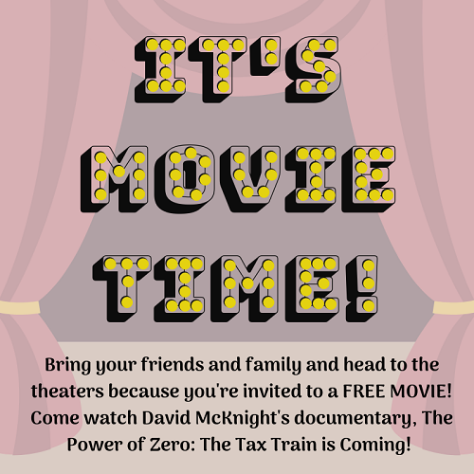

3. We need at least 80 people to sign up for the free viewing of “The Power of Zero: The Tax Train is Coming!” Invite your friends and family and share this post to spread the word! RSVP today: [theater landing page]
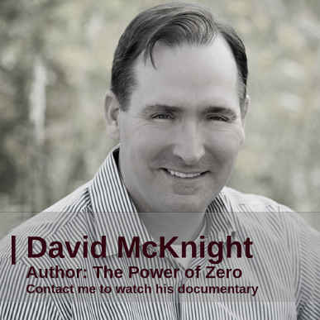

4. Hear from some of the leading industry specialists like Ed Slott, Maya Macguineas, Tom Hegna, Van Mueller, David McKnight, Nada Eissa, and more about what we can do to prepare for the debt crisis! RSVP today: [theater landing page]
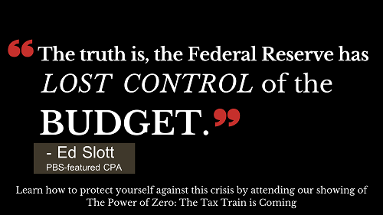

5. Why do we need to prepare now – haven’t we been in debt for years? One reason is that people’s retirement savings are at risk of future higher taxes. RSVP today to learn more: [theater landing page]
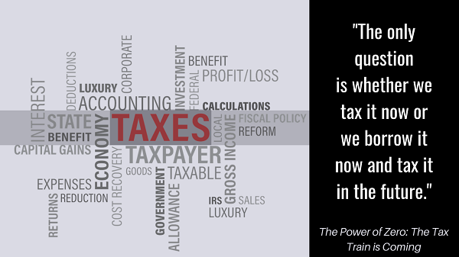

6. David McKnight has been travelling around the country for 4+ years, talking to specialists and gathering information on how the debt crisis may soon affect us. I invite you to join our live screening event of his new documentary “The Power of Zero” – RSVP today! [theater landing page]
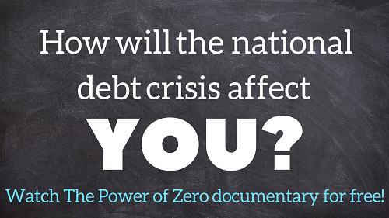

7. “I am driven to help as many people as I can avoid this disaster that’s going to come up in retirement when taxes go up and the market goes down. What are the people who didn’t plan ahead going to do?” – Tom Hegna, Author of Don’t Worry, Retire Happy! Learn more about this issue and how to protect your retirement at our live screening event! RSVP here: [theater landing page]

8. The U.S. is in debt, but just how much debt? (I wonder how much it’s grown since I made this post!) Learn about our national debt crisis from watching our screening of David McKnight’s new documentary “The Power of Zero: The Tax Train is Coming.” Get signed up today: [theater landing page]
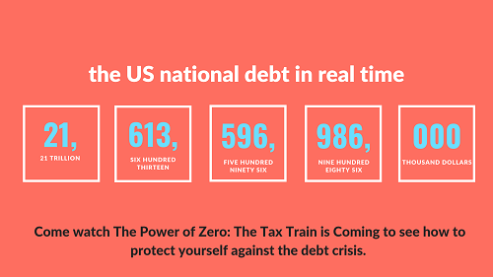

9. This is what our nation’s debt looks like. See the issue? Learn more about it at the event I’m hosting! RSVP today: [theater landing page]
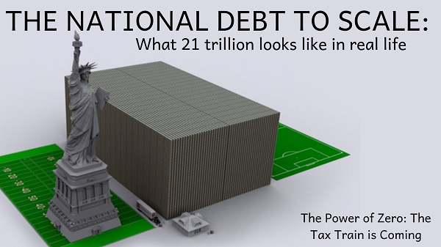

10. *REMINDER* - it’s not too late to sign up for the free screening of David McKnight’s new documentary, “The Power of Zero: The Tax Train is Coming.” Bring your friends and family! RSVP today: [theater landing page]

11. The US debt may be setting the stage for massive tax increases. Check it out in my free screening of McKnight’s newest documentary! Get signed up today: [theater landing page]
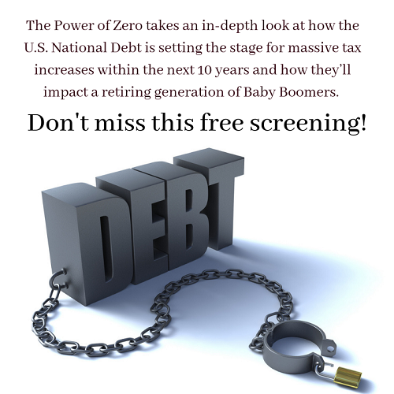

12. Did you register yet?! Don’t forget to RSVP and mark your calendars! RSVP here: [theater landing page]
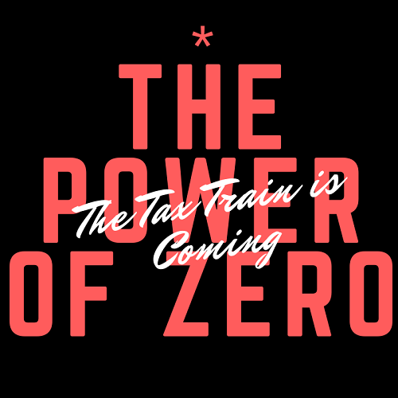

13. Attention baby boomers, listen up! You may want to consider watching The Power of Zero: The Tax Train is Coming, as you may be affected the most. RSVP today: [theater landing page]
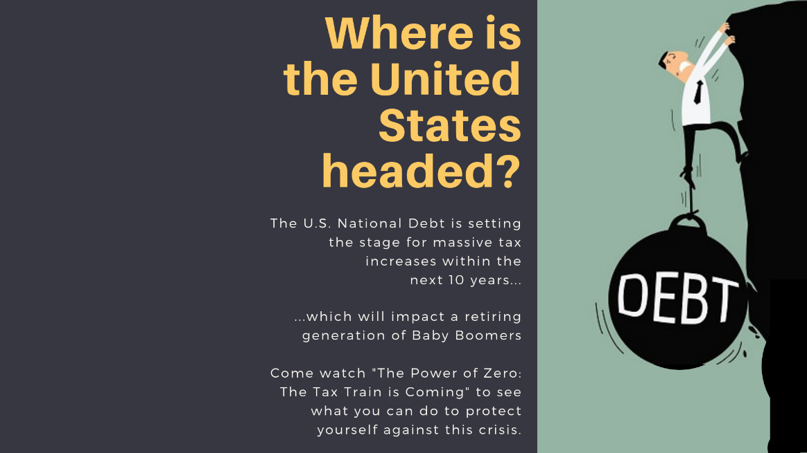

14. The national debt is rising – are you adequately prepared? Come join us in watching The Power of Zero: The Tax Train is Coming! Sign up here: [theater landing page]
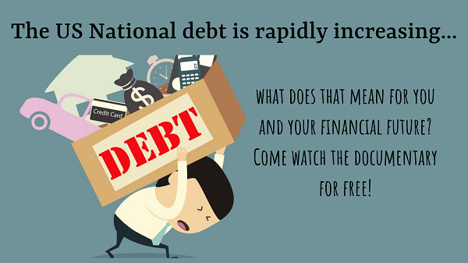

15. It’s almost movie time! Email me or call my office if you’re interested in attending The Power of Zero: The Tax Train is Coming. Hurry, times running out! RSVP now: [theater landing page]

TWITTER
1 . You’re invited to see The Power of Zero: The Tax Train is Coming by @mcknightandco RSVP: [theater landing page]

2. Learn about the nation’s #debt crisis! RSVP to join: [theater landing page]

3. We need 80 people to sign up for the free viewing of “The Power of Zero: The Tax Train is Coming!” RSVP here! [theater landing page]
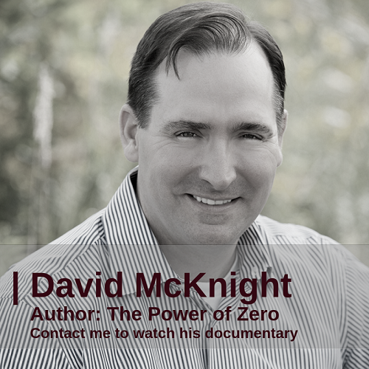

4. Hear from some leading industry specialists about what we can do to prepare for the #debtcrisis! RSVP here: [theater landing page]

5. Why do we need to prepare for the debt crisis now? Well, people’s retirement savings are at risk of future higher taxes. Come watch the documentary we are screening to learn more about it! RSVP here: [theater landing page]

6. Friends! @Mcknightandco explains how the debt crisis may soon affect your retirement. Come join us in watching his documentary! RSVP now: [theater landing page]

7. “What are the people who didn’t #plan ahead going to do?” Sign up to watch David McKnight’s new documentary to learn why your #retirement is at risk and what you can do about it: [theater landing page]

8. The US is in #debt, but just how much debt? (I wonder how much it’s grown since I made this post!) RSVP to join our movie night to learn more: [theater landing page]

9. This is what our #nationaldebt looks like. See the #issue? RSVP to join the debt #documentary here! [theater landing page]

10. It’s not too late to sign up for the free screening of David McKnight’s new documentary! RSVP here: [theater landing page]

11. The US debt may be setting the stage for massive tax increases. Come learn what you can do about it! RSVP here: [theater landing page]

12. Did you register yet?! Don’t forget to RSVP and mark your calendar! Sign up here: [theater landing page]

13. Baby boomers – check out @mcknightandco’s new documentary on #taxes in #retirement, as you may be affected the most. RSVP and tell your friends! [theater landing page]
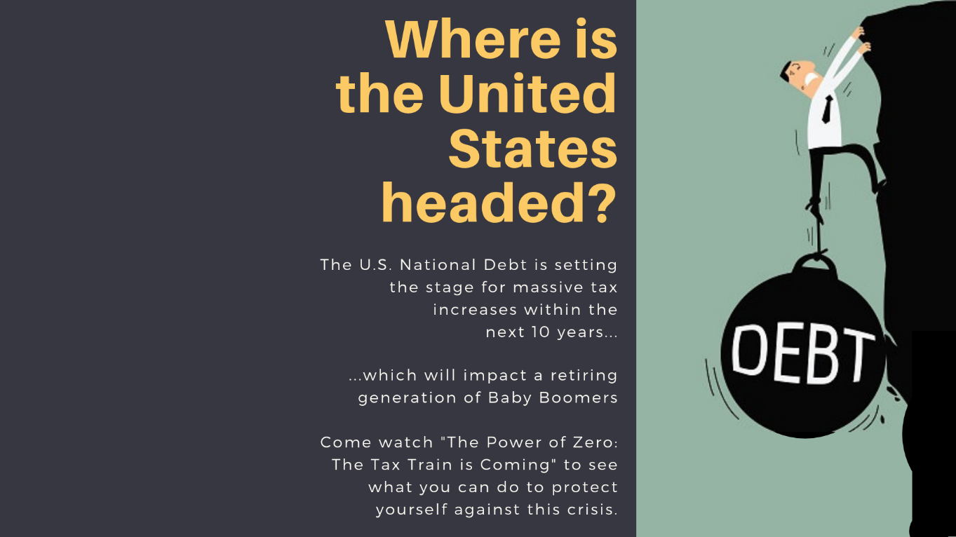

14. The #nationaldebt is rising – are you prepared? Come watch @mcknightandco’s #documentary with us! RSVP here: [theater landing page]

15. It’s almost movie time! Join us in watching The Power of Zero: The Tax Train is Coming. RSVP here: [theater landing page]

